Assiengment no:05

Create repository named hotel booking website and push the same to GitHub

Index.html

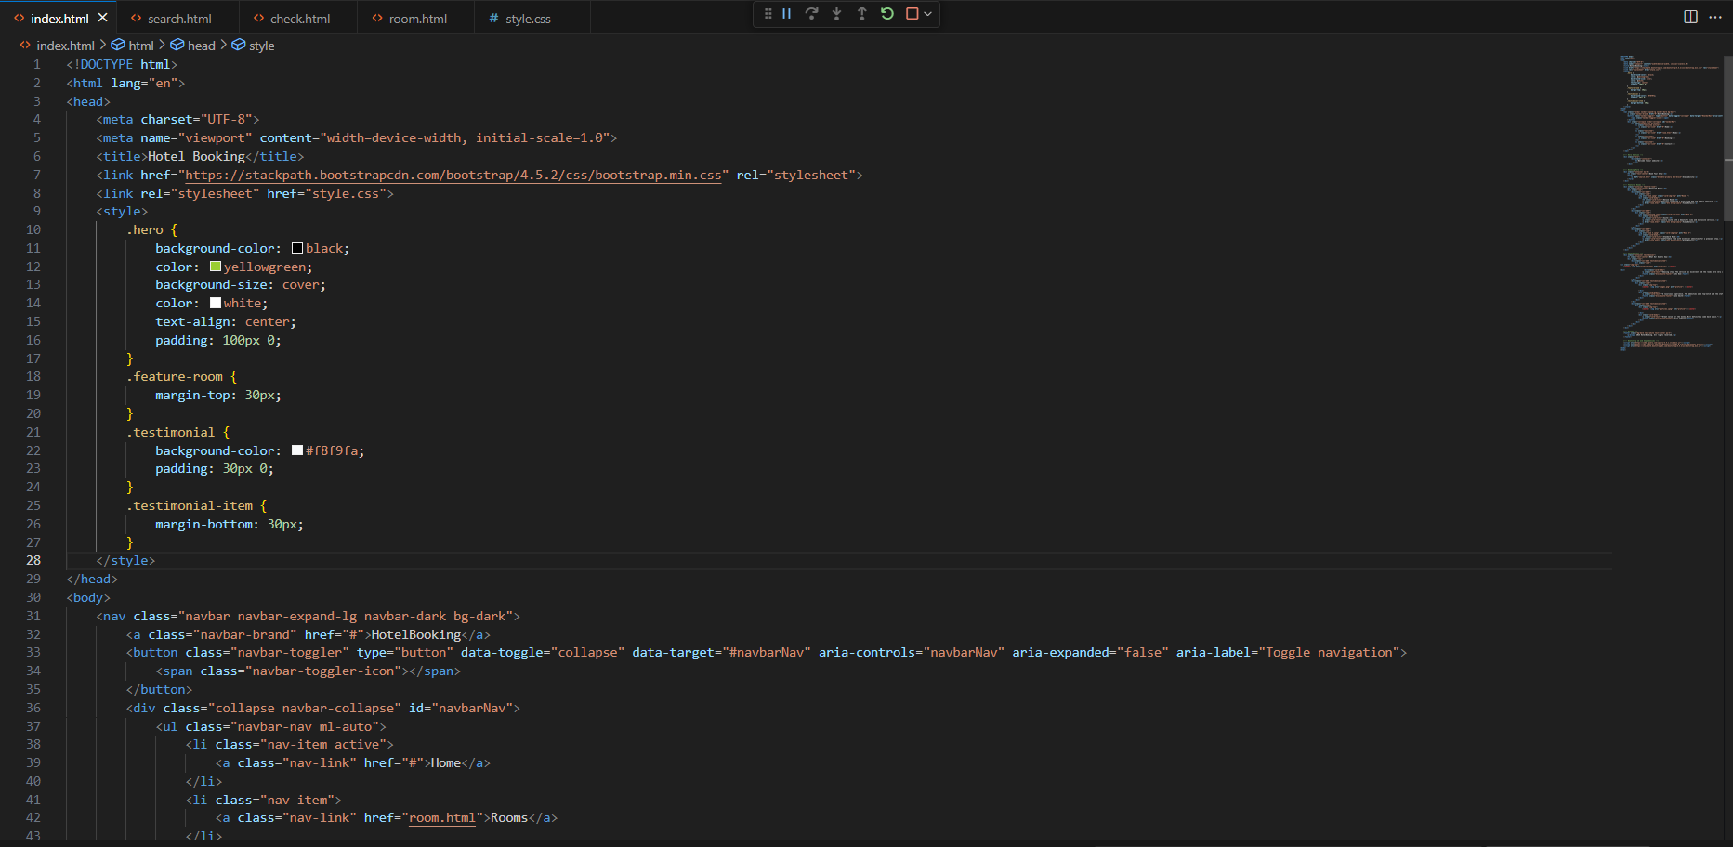

Search.html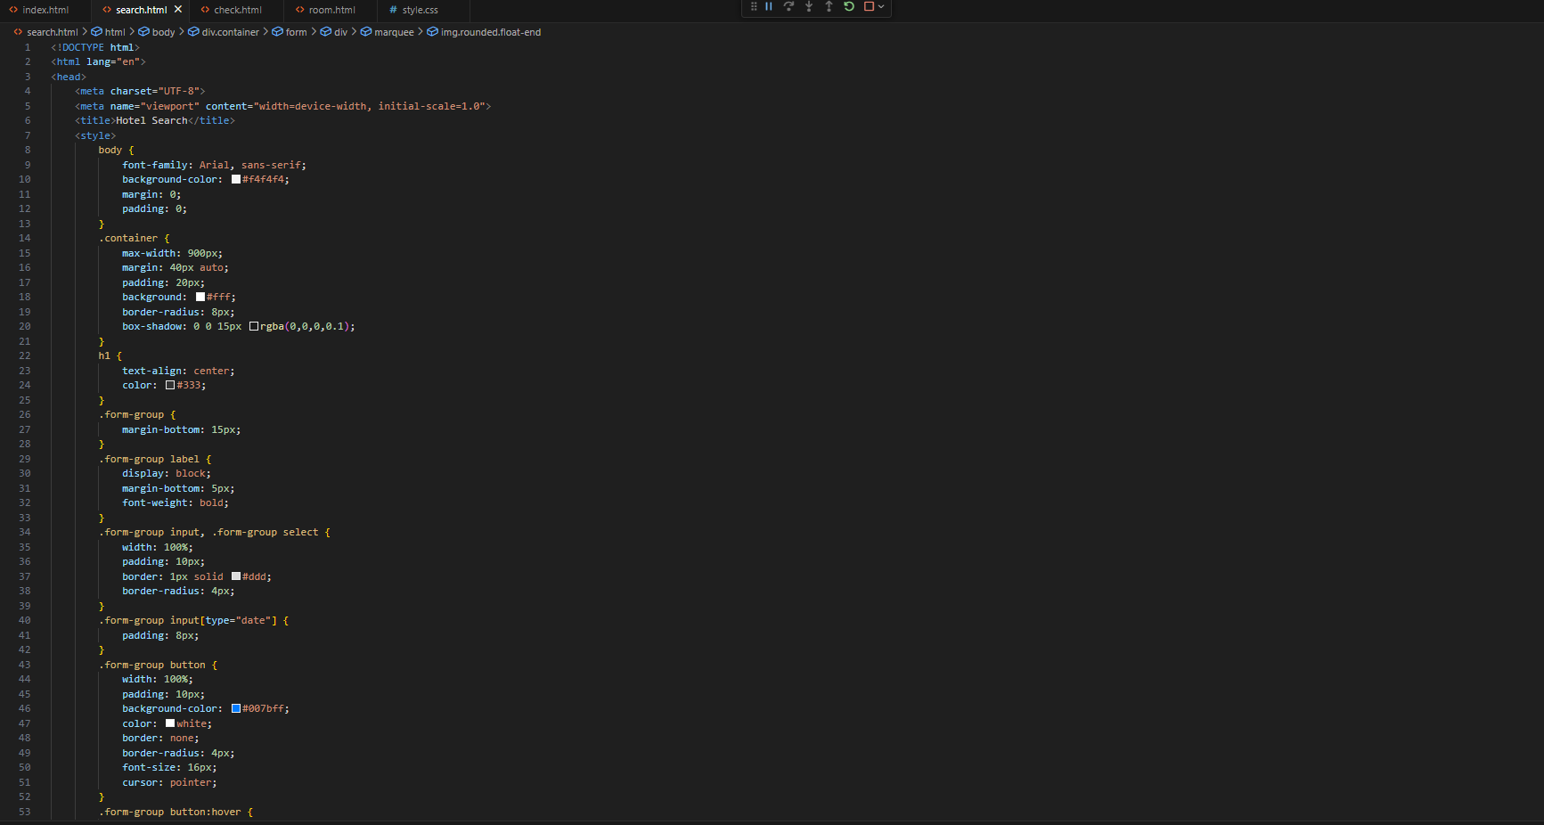

Check.html

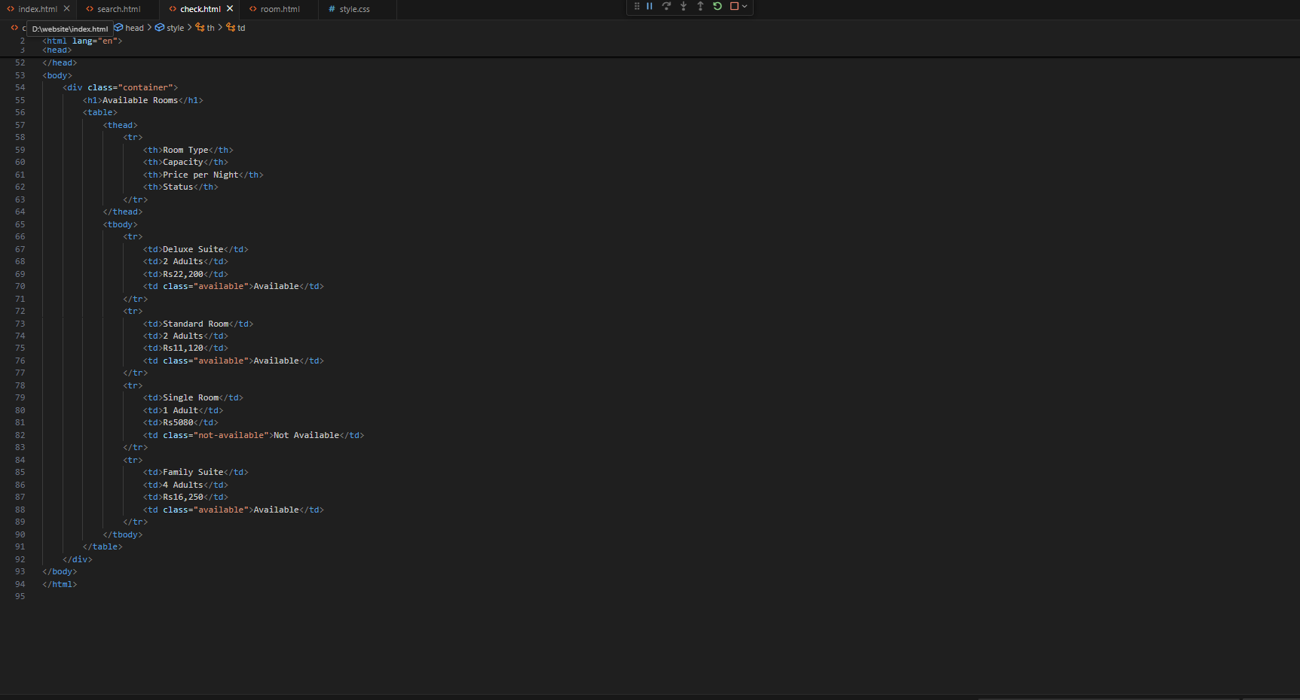

Room.html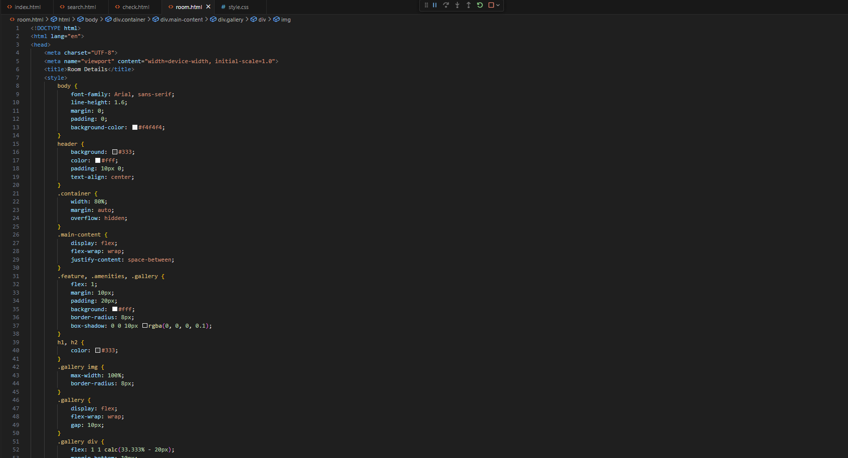

**Output**:

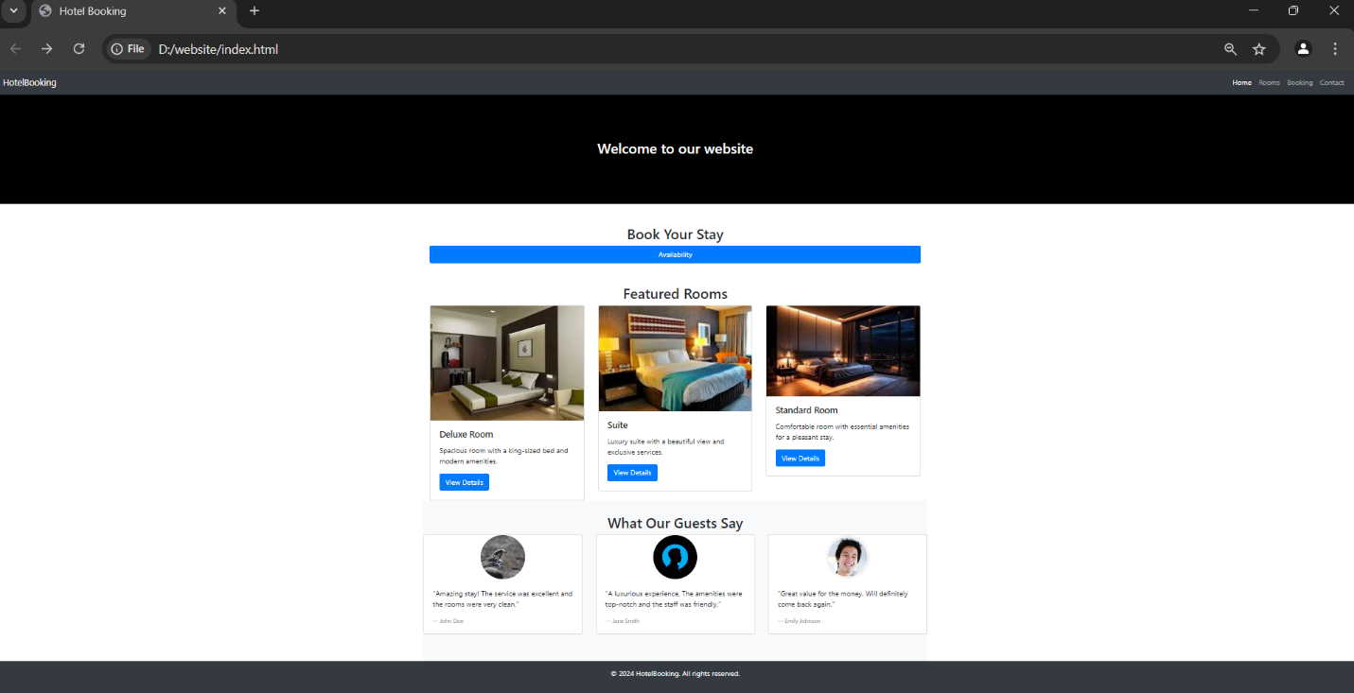

**Step 1: Create a New Repository on GitHub**

1. Log in to GitHub -https://github.com and log in to your account.

2. Create a New Repository:

• Click on the "+" button in the top right corner.

• Select "New repository" from the dropdown menu.

• Enter a name for your repository (e.g., `college website`).

• Click the "Create repository" button.